

**Climate Bot**

**User Guide**



**Team Members**

Nilothpal Bhattacharya A0269637L

National University of Singapore – Institute of System Science

Full installation and deployment

Follow this section only if you wish to deploy the system locally:

* Please note for setting up this bot to operate on your system you need the following things
  + System Requirements and Dependencies:
    - Browser: Google Chrome
    - Windows 7 and above OS
    - Works on both 32-bit as well as 64-bit systems(Laptop/PC)
    - Works directly on Android/Apple phones
* The chatbot can be accessed directly using this link <https://t.me/ClimateSGBot> . If you have Telegram then you can access it directly.
* For testing shared the chatbot on WhatsApp, workable model

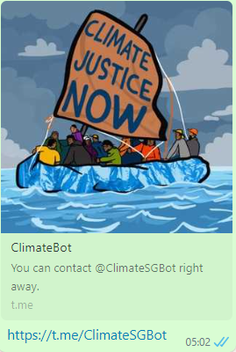

* The setup is straight forward if you like to set-up this by yourself on your system, you need to have:
  + Google Account
  + Telegram Account
* The main thing here is setting up the knowledge base in DialogFlow for Climate related questions to be setup as FAQs. You can use the Knowledge Base documents that I have created to test your setup that you simply need to upload to GoogleDialogFlow >Knowledge Base.

Initial screen of the bot:

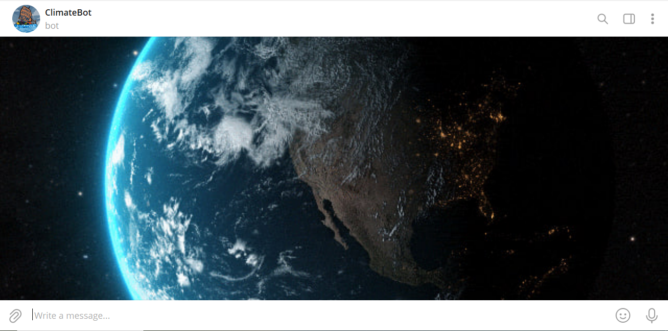

Initial interaction with chatbot started . Try with some initial keywords like climate change, El Nino, GHG etc.

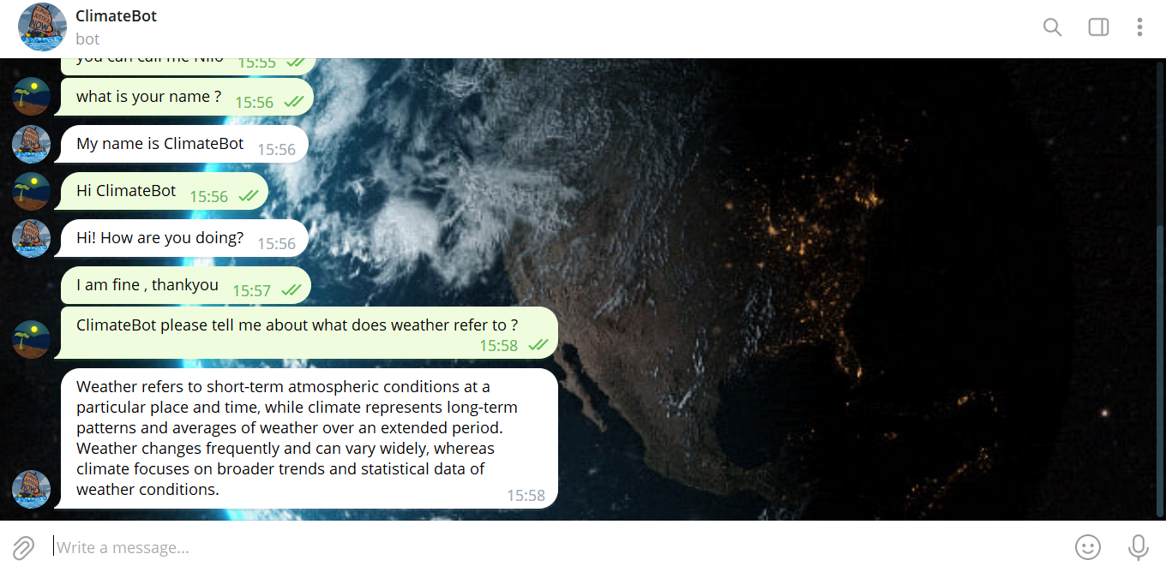

Asking climate related questions

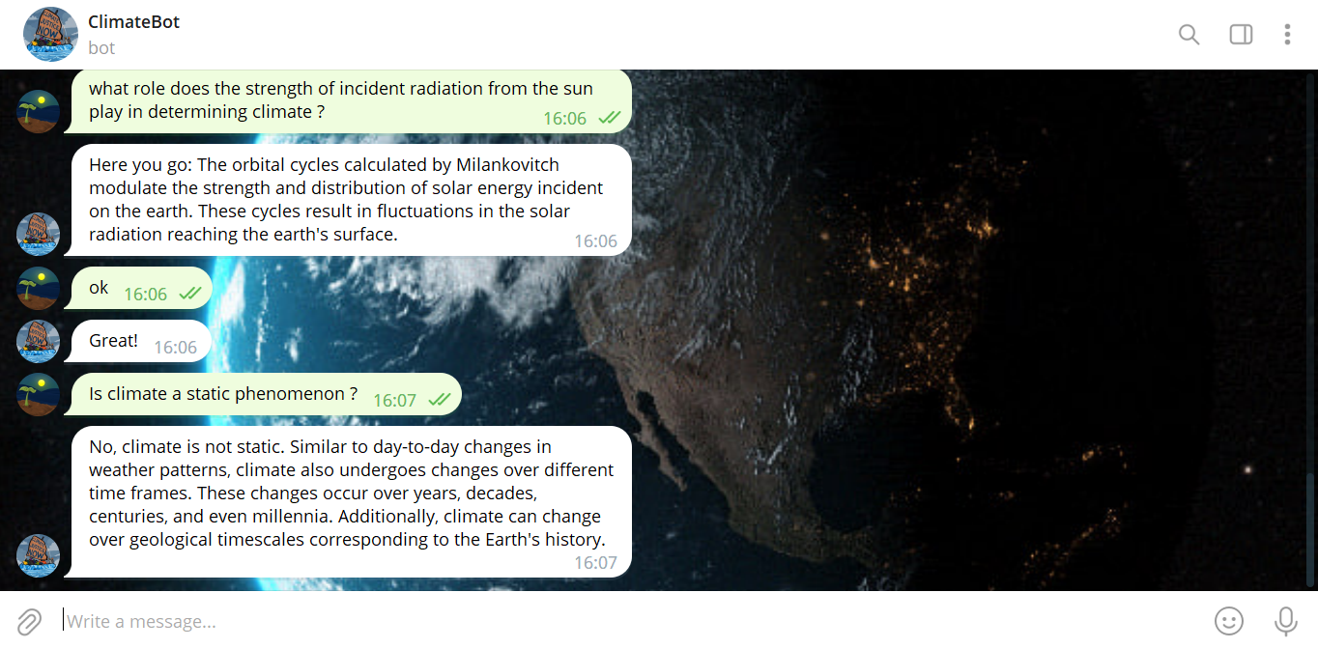

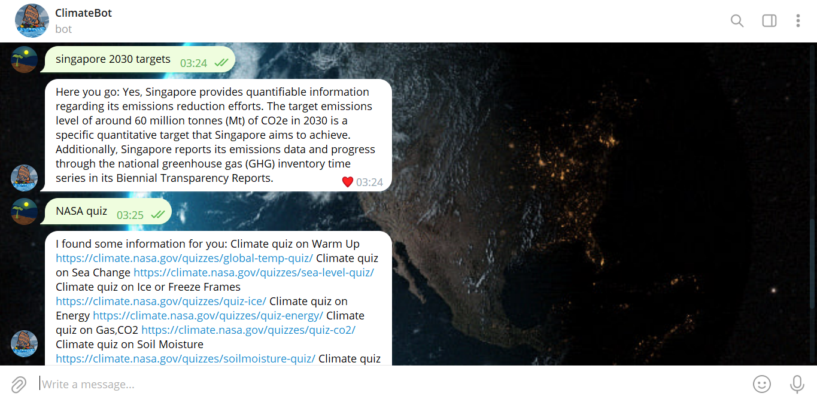

Some quizzes can be accessed here

